**Problem Description**

For this problem, given a text file, I was to remove the control characters using Java, Python, and Perl. This was a bit tricky, because I had to ensure that when I read in the files in each language, it would preserve all the control characters. To verify this, after I read the file into a string in each program, I wrote it directly back to a new file and checked it in Vim on the lab computers (I removed the code that did this for my final submission). All my programs preserved the control characters correctly, so I proceeded to elimination. To do this, I mostly used regular expressions to filter out the control characters. In Java, I used replaceAll to replace the control characters with an empty string using a regular expression. I then wrote the result to a new file and verified it in Vim. Perl has a regular expression to get rid of all non-printable characters, so I implemented that and once again wrote the results to a new file and verified in Vim. As for Python, the approach was a little different. I used a lambda function that would create a new string out of characters only in the code point range between 32 and 126. This eliminates all control characters and other non-printable characters. I then printed the output to another file and verified with Vim once again.

**Java Code and Output**

/*

*Joseph Camacho-Terrazas

*10/26/2020

*Input: The backup text file

*Output: Resulting string after eliminating control characters

*Preconditions: The file must exist and filename must be valid

*Postconditions: Print the resulting string after eliminating all control characters

*/

import java.util.*;

import java.nio.file.*;

import java.io.*;

public class ControlChar {

    public static void main(String[] args) {

        try {

            //Create a path to the text file and read it into a string

            Path file = Paths.get("control-char.txt");

            String originalString = Files.readString(file);

            //Create a new string, perform control character removal using regex and print the results

            //Regular expression source: https://howtodoinjava.com/java/regex/java-clean-ascii-text-non-printable-chars/

            String modifiedString = originalString.replaceAll("\\p{C}", "");

            //Create a new file to store the output and check if it already exists

            File output = new File("javaoutput.txt");

            if(output.createNewFile()) {

                System.out.println("File created successfully " + output.getName());

            }

            else {

                System.out.println("File exists");

            }

            //Create a filewriter and write the new string to the file and close it

            FileWriter newWriter = new FileWriter("javaoutput.txt");

            newWriter.write(modifiedString);

            newWriter.close();

        }

        catch (IOException e) {

            //Catch any IO Exceptions

            System.out.println("There was an error" + e);

        }

    }

}



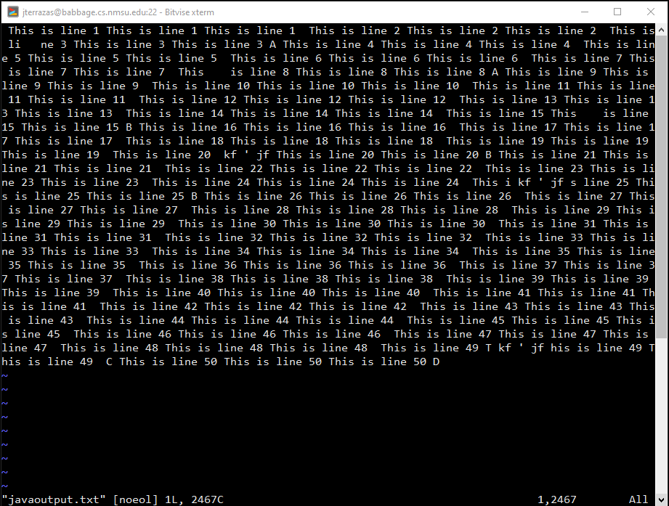

**Perl Code and Output**

#Joseph Camacho-Terrazas

#10/26/2020

#Input: The backup text file

#Output: Resulting string after eliminating control characters

#Preconditions: The file must exist and filename must be valid

#Postconditions: Print the resulting string after eliminating all control characters

#!/usr/bin/perl

use strict;

use warnings;

#Create variables for the input and output files

my $inputFile = "control-char.txt";

my $outputFile = "perloutput.txt";

#Create an empty string to read the file into

my $myString = "";

#Open the input file read-only, loop through until EOF, and place each line into the string

open FILE, "<", $inputFile or die "Can't open the file! $!";

while (<FILE>) {

    $myString .= $_;

}

#Perform a regex match on the string to eliminate non-printable characters

#Regular expression source: https://stackoverflow.com/questions/7406037/how-to-get-rid-of-control-characters-in-perl-specifically-gs

$myString =~ s/[^[:print:]]+//g;

#Create a new file for output, and print the results to the file

open FILE, ">", $outputFile or die "Can't open the file! $!";

print FILE $myString;

print "File created successfully $outputFile\n"



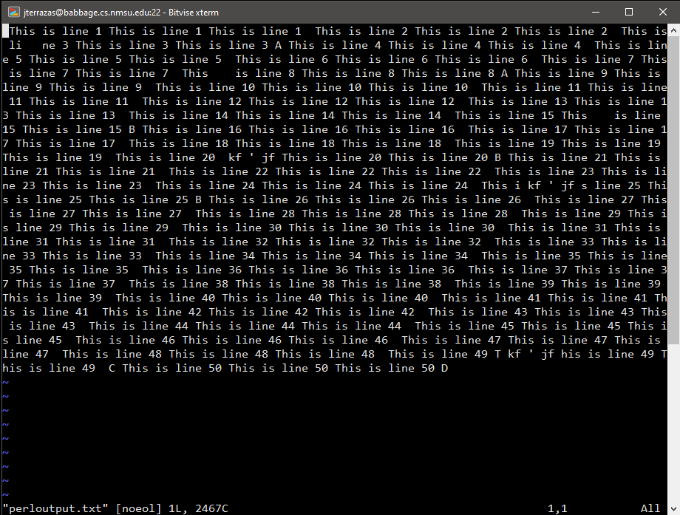

**Python Code and Output**

#Joseph Camacho-Terrazas

#10/26/2020

#Input: The backup text file

#Output: Resulting string after eliminating control characters

#Preconditions: The file must exist and filename must be valid

#Postconditions: Print the resulting string after eliminating all control characters

import string

#Open the input file and place in a string

f1 = open("control-char.txt")

originalString = f1.read()

#Open the output file for writing

f2 = open("pythonoutput.txt", "w")

#This labmda function will create a new string out of only printable characters (code point range 32 through 126)

#Function source: https://rosettacode.org/wiki/Strip_control_codes_and_extended_characters_from_a_string#Python

modifiedString = lambda x: "".join(i for i in x if 31 < ord(i) < 127)

#Write the result to the file

f2.write(modifiedString(originalString))

print ("File created successfully ")

print (f1.name)

#Close all open files

f1.close()

f2.close()



